Regulatory Analytical Paper
ECO- 540
Dr. Edwards
12/22/24

Historical Background
The U.S. Department of Justice DOJ was founded in 1870 and serves as an executive department responsible for ensuring public safety though its enforcement of laws and actions. Within the DOJ lies the Antitrust Division. Established in 1933, this division’s sole purpose is to promote economic competition through enforcement of antitrust laws and is rooted in preventing monopolistic practices though legislation and action. Primary among these include the Sherman Act of 1890 as well as the Clayton Act of 1914. The primary action in this case is to assess and prevent any merger or consolidations that could disrupt competition or lie in violation of section 7 of the Clayton Act of 1914. The scope of this mission is found in the analytical tools such as HHI, potential anti-competitive effects as well as accessing the implementation of economical models to determine competitive outcomes. (U.S. Department of Justice, n.d.-a) (U.S. Department of Justice, n.d.-b) (U.S. Department of Justice, n.d.-c)
With this, there have been significant changes to the calculation and determination of horizontal merger guidelines that have included support from the Federal Trade Commission that includes unilateral and coordinated effects of merger situations. In addition, case specific analysis and customer substitution patterns have also been added to provide a modern economic scope to address anticompetitive behaviors in markets. (Peters and Wilder, 2021) Additionally there have been great scrutiny in dealing with vertical merger situations at differencing supply chains. In general, this has come under some inspection from authors like Salop and Culley which state that overreliance on behavioral remedies such as commitments to fair practices have outshined divestitures and other structural remedies found to be more effective at the preservation of competition. (Salop and Culley, 2020) Additionally, some have seen these significant changes in policy implementation as more interventionist, citing those theories of harm both in terms of the DOJ’s failure to account for dynamic markets in terms of technology and innovation as well as understated effects of vertical integration deals and their potential efficiencies. (Manne & Stout, 2020) This is also sympathized somewhat by A. Douglas Melamed expanding his criticisms of antitrust law as too limited in its focus on consumer welfare as opposed to labor markets or innovations. Additionally, complex theory’s he states provide many defendants to find holes in theories and dispute claims. (Melamed, 2020) Some view these analytical tools with great flexibility, seeing the DOJ as now having the ability to tackle and delineate violations and circumstances with greater breadth and range. (George Mason Law Review, 2023)
Key Issues
The key salient issues that pertain to the DOJ regarding this merger include marketing concentrations and the reduction of competition. In addition, issues such as slot dominance, coordinated behaviors as well as their impact on customer fares and surpluses are crucial for the DOJ. For example, the Government Accountability Office had noticed the behaviors of such airlines mergers and predicted that control of substantial shares of the airline industry market would lead to higher fares and decreased competitive pressures. Also, slot dominance was of primary concern especially at Regan National Airport where it controls a significant takeoff and landing slots. (Government Accountability Office, 2013). This was substantiated by Douglas Turners evaluation of the merger situation citing that before the merger situation, US Airways route structure proved a deterrent to collusion but due to the homogeneity post-merger, coordinated prices could be vastly more plausible thus harming consumers though higher fares. (Turner, 2022) Lastly, empirical analysis done by Wharff, M. (2023) used differences in differences approach to look at the domestic pricing effects. He found small but significant fare increases in markets effected by the merger. However, overall consumer welfare remains ambiguous in the study and retained that while some customer may have seen pricing increases, others may have benefited from expanded networks and improved services post-merger. (Wharff ,2023).
HHI Concentration for Top 10 Markets
Mathematical Steps for Calculations for City Pairs
For the calculations for city pairs and output tables presented in this paper, I applied the following mathematical procedures. Firstly, I had to break down the data file in the T-100 using the following parameters of carrier. (Bureau of Transportation Statistics,2012). would consist of American Airlines or US Airways pre-merger and American Airlines Inc or Group post-merger. Next, market share was calculated as the passengers from American Airlines and US Airways combined (pre-merger) and then the consolidated merger (post-merger) over the total passengers indicated on that specific city-pair segment. Lastly, I then squared the market shares to achieve HHI concentrations of these city pairs and filtered them to include the ones in which the most market share or HHI concentrations are prevalent. Though this isn’t always accurate, I used multiple metrics and converted them to precent to then represent the HHI concentration that American Airlines or US Airways would have in the Top Markets regardless of total market control. This is for pre- and post-merger. I expressed this in 2012 as a percent for perspective. Then I showed the hard HHI concentration calculations for more accurate representation for both 2012 and 2014. Some filtering was done with high demand markets which was operationalized as passengers exceeding 100,000 to give a representation of the sheer level of monopolistic control from the data set that the post-merger presented in directing these city-pair markets to illustrate potential antitrust concerns.
Top 10 City Pair Markets 2012 Pre-Merger
Top 10 Market Pre-Merger Domestic Market was obtained using T-100 Market Carrier with the following parameters to accurately depict concentration. These include passenger transported, seat availability as well as number of flights operated. (Bureau of Transportation Statistics BTS, 2012). I then filtered down the data for only American Airlines and US Airways to then look at the concentration for the highest top 10 markets pre-merger that one of these airlines will have the largest share. Then I will look at post-merger market concentrations for comparisons as to how the merger will impact city pair flights. Below I have put the Top 10 City-Pair markets and who had dominated control over these flights.
The table below represents top markets in which American Airlines or US Airways have total market control. Note that some of these city pair are very small with one or two departure flights. The number 1 indicates total monopolistic control.

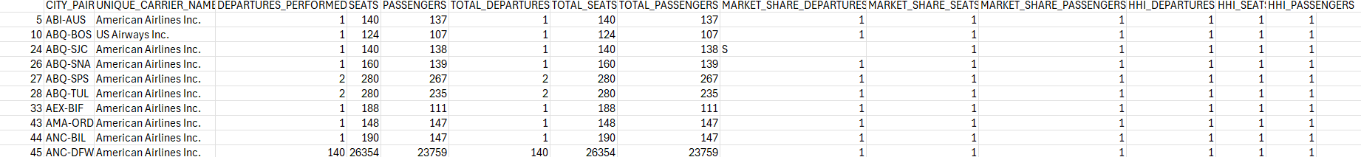
Now we will look at how American Airlines and US Airways stack against the Top City Pair markets over all and how each airlines concentration and market share look in 2012.
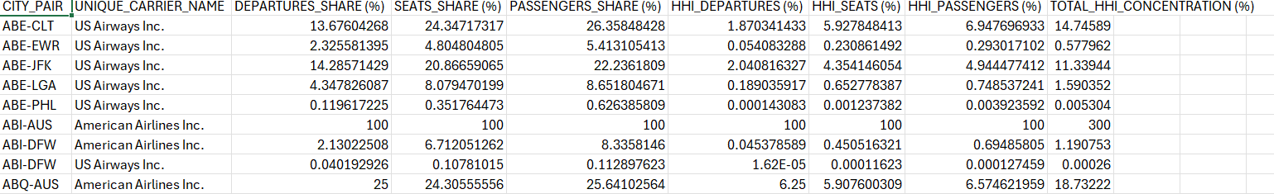
Here we can see the reference of the Top 10 Markets that the combined American Airlines and US Airways have in terms of HHI concentration pre-merger. Notice the swaying of passenger counts as one dominates a partial route and the other doesn’t.
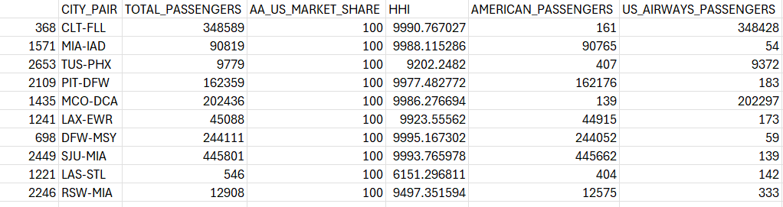
However, one of these routes appears to be a non-domestic flight so I imputed a closer domestic flight city pair that also has high concentration.
This concentration also indicates huge control over these domestic routes.
Here we can see that pre-merger U.S Airways and American Airlines occupy a significant portion of control though seating, seat shares (stated from previous chart) as well as passengers. Additionally, both airlines show a significant portion of control when factoring in Top Markets overall with 14 percent control in ABE-CLT city pair as well as 11 percent total control in ABE-JFK.
Top Hub Data Pre-Merger and Post-Merger
To provide the calculations for the pre- and post-merger top hubs, I focused on historical verification of the top hubs for these respective airlines independently (Bureau of Transportation Statistics [BTS], 2012) (Federal Aviation Administration [FAA], 2012) (MIT Airline Data Project, 2012) (International Air Transport Association [IATA], 2012). Afterwords, these are then applied to the information regarding enplanement data to isolate the following calculations and concentrations pre-merger for 2012 and post-merger information for 2014. In addition, the T-100 enplanement data illustrates passengers by count and routes helping us pin down concentrations. Here are the following results for 2012.
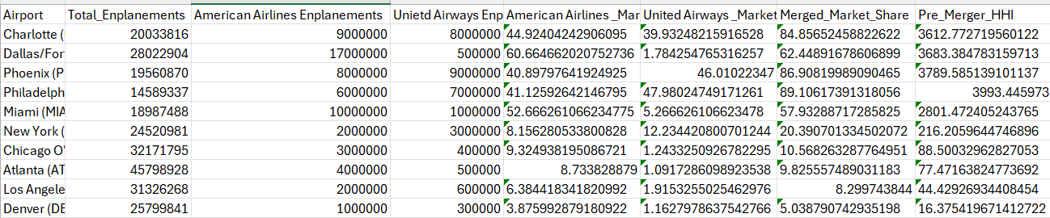
The following mathematical procedures were performed to get an estimate of the top hubs for concentration. First, let’s use Charlotte (CLT) as an example. Market Share is calculated as Market Share=Total Enplanements of Airline​​×100. Next, we will take the American Airlines portion of the enplanements (9,000,000) and divide by 20,033,816 and times 100 to yield 9,000,000/20,033,816 ​×100=44.92%. Now let’s take United Airways Enplanements for a calculation of 8,000,000/20,033,816​×100=39.93%. Moving along we now need to square the market shares of both airlines percentages to receive the Market Share for the individual HHI. From American Airlines and United Airways, we have subsequently the following output. (44.92)^2=2018.74, (39.93)^2=1594.03. With these calculations in place, we will now take the sum of these squared market shares and calculate the total. This will yield 2018.74+1594.03=3612.77. We can see from what we know about HHI that any calculations over HHI > 2,500: show high concentrations. (U.S. Department of Justice, 2015)
Post Merger Hub 2014 Data.
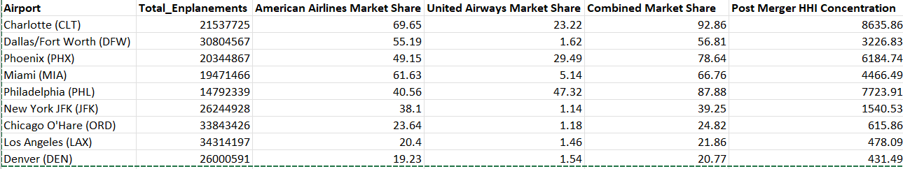

Significance of Ratio for Addressing Salient Issues
Market Concentration and Reduced Competition
The significance of these ratios is vital to the salient issues in a variety of ways. Primarily, the pre-merger data indicates that city-pair markets such as Charlotte-Dallas show pre-merger HHI concentrations over 4,000. This well exceeds the 2500 threshold for high concentrated markets. Additionally, key routes such as Washinton D.C (Reagen National) to Boston as well as Miami to Dallas and Charlotte to New York have combined dominance of almost 35-50 percent market share. A merger situation could very well exasperate these numbers and suggest even more elimination of competition in these market pairs. These could have drastic consequences including collusions or other monopolistic practices.
Slot Dominance
The briefing on the subject listed Reagan National as controlling 55 percent of the slots creating significant barriers to entry. (Government Accountability Office, 2013) Post merger increases will put this number at almost 69 percent with a calculated 3000 HHI concentration. With post-merger situations, we will see these numbers rise and thus effectively curtail. This could create huge barriers to entry as well as prevent expansion from competitors.
Consumer Welfare and Impact on Fares
Some routes such as Charlotte-Philadelphia exceed 3500 in HHI concentration. With the pre-merger combined market share of 40-45 percent. Substitution patterns from the data suggest that other carriers like Delta as well as United had minimum significance or presence on this route. This could create significant problems for customers to find alternatives in pricing (from lower cost carriers) as well as projections into post-merger illustrating passengers paying higher fare prices for similar or reduced services. (Wharff, 2023)
Key Regulatory Instruments
There are a variety of regulatory instruments that could be of use in controlling market power as well as addressing coordinated behaviors and aiding in consumer welfare. Principally, structural changes like divestitures can restore competition and enable entrants into important industries to better consumer wellbeing. (Kwoka, 2015) Additionally empirical studies have found that divestitures, when implemented in post-merger scenarios, can maintain competition and outcomes. (Kwoka, 2015) However, it should be noted that though divestitures can help the robustness of competition, scaling disadvantages after divestitures as well as in high fixed cost industries, can render divestitures insignificant. Even after their implementation, dominate firms may still exert significant pricing and output controls, stifling competition. (Salop & Culley, 2020) Another potentially effective instrument could be behavioral remedies such as conduct-related obligations or fair practice commitments and transparencies. One interesting component of these procedures is that it can be tailored to dynamic market situations and used to address specific situations such as customer substitution patterns. This is very important in that routes or hubs with airline dominance, reduce the choices available to customers such as switching airlines or modes of transportation. The measure of elasticity in consumer demand can create context specific and granular adjustments post-merger to allow customer options and alternatives. (Peters and Wilder, 2021) One major issue with this approach is its labor intensiveness as well as it lacks overall long-term effects. It has also been shown lack enforcement strength and have been used excessively by the DOJ. (Salop and Culley, 2020) Other techniques that can be used include slot and market entry controls as well as economic modeling and forecasting. This was previously used by the DOJ in Regan National Airport (Government Accountability Office, 2013) and can lead to direct competition in concentrated markets as well as improve pricing competition. However, success can only depend on if new entrants can still effectively compete. Additionally, this still doesn’t prevent the high barrier to entry within the industry and its deterrents. (Government Accountability Office, 2013) Lastly HHI concentrations and economic modeling such as applied by the DOJ to this case can provide evidence-based proof for excessive market concentration as well as provide granular data on route specific concentrations that can then be mitigated using various techniques listed above. (Turner, 2022). It should be told with caution that these techniques might not be able to address subtle network effects as well as route complementariness in how major airlines can affect smaller markets and major hubs. (Melamed ,2020)
Imperfect Information
One key stakeholder involved in the implications of imperfect information and its effects on economic decision making are the customers who operate and function within the airline industry. After the merger, consolidation reduced competition found on numerous routes and due to this, pricing fares may begin to raise and in certain markets. (Turner, 2022) (Bontemps, Remmy, & Wei, 2020) Simultaneously, route availability and frequencies were changed, customers may not have been aware of these changes or may not have understood the scale of these impacts due to limited understanding of the merger’s competitive dynamics. One example of this was the analysis of this merger by Bontemps et al. (2020) which looked at the consumer surplus of markets in which both airlines operated and then accessed surplus after the merger took place. It was found that consumer surplus that in which both airlines operated increased while post-merger (with one operative airline) consumer surplus dropped. This could suggest that customers, lacking specific information may have had to face significant changes to service availability and pricing post-merger but isn’t definitively proven. (Bontemps et al. 2020)
Other stakeholders could include the airlines themselves. For example, Moss (2013) found that anticipated efficiencies from the merger may not materialize as expected. (Moss, 2013) Additionally, though consumer welfare increased from network optimizations, these efficiencies were only a portion of the mergers projected benefits. This shows that the airlines had an inability to anticipate the operational complexities such as overlapping routes or alignment of services post-merger. (Bontemps et al, 2020) This was also coupled by Das 2019 which looked at how mergers in general can focus on city-pair markets but underestimate the competition of low-cost carriers in certain markets can erode expected gains and profits. (Das, 2019)
Other shareholders could include competitors as well as regulators. For instance, competitors faced challenges in predicting pricing as well as route structures and capacity decisions regarding the merger situation. (Bontemps, Remmy, and Wei,2020) (Turner, 2022) This was also expressed generally in Remer & Orchinik (2024) which concluded that alterations to most post-merger situations can lead to higher fares and reduced competition, but the degree can create uncertainty about how to respond to these situations. This is because factors such as route expansions, service offerings etc. are largely unknown or unclear in immediate post-merger procedures. (Remer & Orchinik, 2024) There is also imperfect information regarding the remedial and predicative effects of regulatory instruments and their effects discussed above and expounded by The Government Accountability Office in its assessment of the 2013 merger. (Government Accountability Office. ,2013)
Calculations of Ratios
Top 10 City Pairs Post-Merger 2014
2014
Here is the Top 10 Markets in which the merged airline will have the highest control and market share. This dataset will be for 2014 when the full implications of the merger have taken place.
The table below shows us the City Pairs in which the merged airline has the highest concentration of control. I refined the metrics to include one variable (passengers) for better analysis.
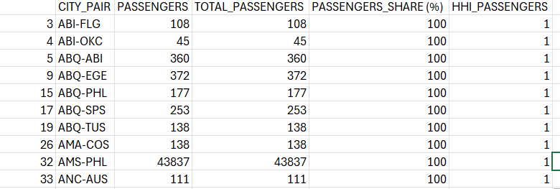
Here we can see that the merger has practically monopolistic control on these specific city pair segments.
Now I will display data on the merger’s contribution as a single entity to the top city pair markets for 2014. This shows the city pair as well as the passengers of the merged airline against the total passengers for the city pair segment. Lastly, I will output the market share of the total passenger metric and its respective HHI concentration. This shows us which city pair market the merger has I used reverse city pairs to provide additional robustness. (U.S. Government Accountability Office, 2014) Please forgive me putting these as decimals instead of percents to show market share.
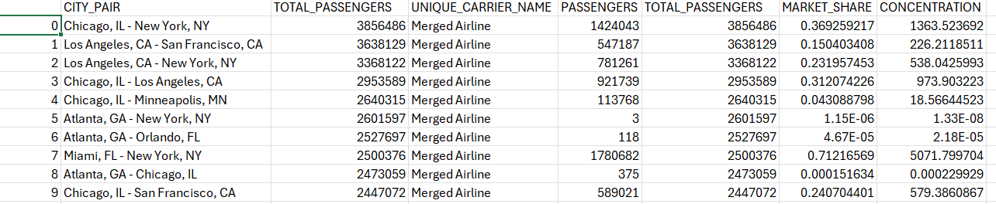
Please note that hub strategies as well as data capturing connecting passenger routed though hubs etc. could provide some ambiguity in the data. (Guimaraes, Soares, & Ventura, 2021) Lastly, I will filter routes that are considered high demand which provide a landscape into the complete control the integrated airlines have over these markets. These markets are listed as having over 100,000 passengers which the merged airline have significant control over.
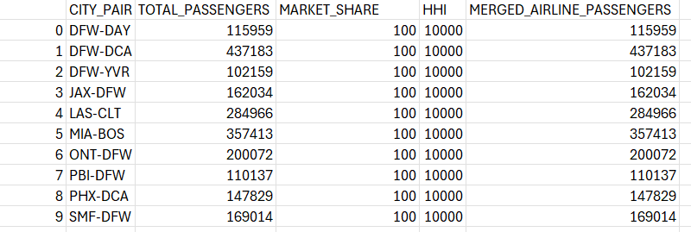
Calculation Steps and End Results
For examples above, I filtered the data to include only passengers where the merged airline operated in 2014. With this, I took the total passengers under the merger airline operation and divided by the sum of passengers from other airlines for that route. Then then calculated the market share. By squaring the marketing share I received the HHI concentration. With these concentrations applied to the dataset I then filtered the data to include only city pairs with total 100 percent control. For a mathematical example, DFW-DAY route pair included 115959 passengers which collectively was the entire route occupation by the merger. This results in 100 precent control of this route pair segment. Then I calculated the merger to the total passengers on the top routes in terms of passenger volume to give an indication of market share and HHI control. Please refer to “Other Mathematical Steps for Calculations for City Pairs” for additional information.
New HHI Estimates and Lost Revenue Calculated
If we assume that US Airways exits the picture the new total HHI concentration for the 10 City Markets will be 3,874.52 with a total loss revenue at 750.3 million USD. I will break this down by City Pair and explain that calculations.
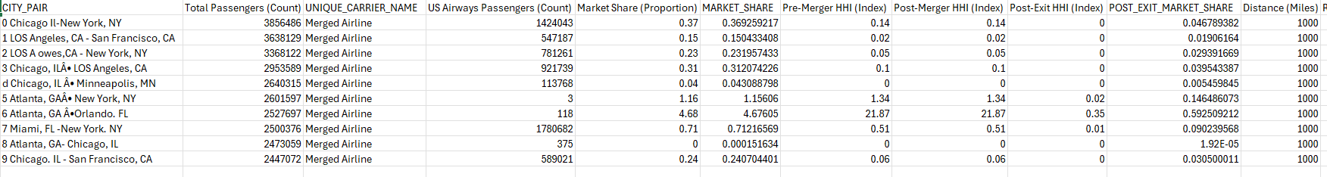
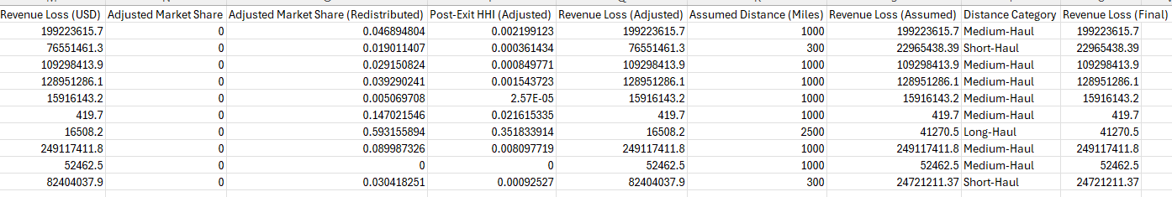
Please ignore the calculation of pre-merger index as this was just filled in as an open variable hence why the pre- and post-merger numbers are the same. The adjusted post-exit HHI concentrations illustrate the market share if US Airways removes themselves from the concentration. Here post-merger is calculated as the combined market shares squared and then scaled by multiplying the sum. This gives us an indication of perfect competition 0 to monopoly 10,000. Just for a random example we can take the market shares 0.52+0.32+0.22=0.25+0.09+0.04=0.38 Scaled HHI=0.38×10,000=3,800. Now for post exit we set adjusted and index market shares to 0 for US Airways and take the redistribution share as the original share divided by the total remaining shares from the dataset. The revenue that is lost is calculated by finding RPM data from 2011 US Airways K-10 and multiplying by the yield in the report. (U.S. Airways, 2012) (United Airlines, 2014) This is then multiplied by the distance for each city pair which I broke down into differing distance categories for easy calculations. This represents the revenue lost if US Airways reduces their market share to 0 percent.
Top Two Hubs Post Merger 2014
Mathematical Calculations for Top Hubs Post Merger 2014
These ratios are calculated using enplanement data and are calculated by filtering American Airlines and US Airways enplanements divided by the total enplanements for the listed hubs. Then I realigned the list to show the highest concentrated hubs. The HHI is calculated by taking the squared of the combined market share for post-merger concentrations. For mathematical example enplanements can be calculated by taking total enplanement time the market share/100. In the following chart I have them listed for reference. Let’s take an example for hub for Charlotte. Enplanement for American Airlines would include the total enplanements for the dataset 21,537,725×69.95(Market Share)/100=15,005,747 Enplanements. The same is calculated for United Airways as 21,537,725×23.22/100= 5,002,853 Enplanements. Market Shares can then be derived by 15,005,747 (American Airlines Enplanement)/ 21,537,725 (Total Enplanement) * 100 =69.95 percent. The combined market share is the addition of 69.95+23.22 for 92.86 percent. HHI is calculated as (69.65) ^2+(23.22)^2 or 4852.92+539.92=8635.85
New HHI Calculations and Lost Revenue from US Airway Exit for Top Hubs

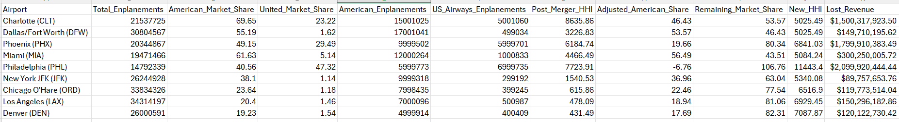
The calculations provided here are as follows. Total Enplanements are listed as 21,537,725. Market shares are calculated as a portion of the enplanement to the total enplanement for that hub. In this example it is 23.22 percent equal the market share controlled by US Airways. To convert this into enplanement we take US Airways Enplanements=Total Enplanements X US Airways Market Share/100. This mathematically looks like this US Airways Enplanements=21,537,725×23.22%/100. Or 21,537,725×0.2322≈5,001,060. Next, we will correct the American Airlines enplanements by taking Total Enplanements= American Airlines Share- US Airways Share/100. This looks like 21,537,725×69.65−23.22​/100 or simply 21,537,725×0.4643≈9,999,966. Now for the new HHI concentration we take the adjusted market share (this was found by subtracting out US Airways market share due to exiting against the total enplanement data) and taking 100%-46.43%=53.57% which shows us the other shares provided by other airlines. Now we square for HHI concentration (46.43) ^2+(53.57) ^2=2157.85+2867.64=5025.49
For Revenue we take the assumption that the average ticket price is 300 USD. This is evidenced around that time by the United States Bureau of Statistics at 390–$410 with one way basis as 200–$250 so I averaged to 300 for simplicity. (United States Bureau of Transportation Statistics, 2015) With this, we take the US Airways enplanement and multiply by the average ticket price to yield 5,001,060×300 or 1,500,318,000 USD. This gives us a general idea of the revenue lost if US Airways were to exit. Yields as well as RPM for USD revenues were pulled from 10-K data provided from 2014 merged data as well as extrapolated data from 2011 but filed 2012 pre-merger US Airways. (United Continental Holdings, Inc., 2014) (United Airlines, 2014) (U.S. Airways, 2012) (American Airlines Group Inc., 2014)
Recommendations
When looking at potential recommendations one of the key alternative approaches would to immediately instill divestitures in over concentrated markets. For example, hubs such as Charlotte and Philadelphia should have divestitures of slot pairs and gates. This could provide a first step to reduce competition and lower concentration levels. In addition, smaller but high revenue markets can encourage smaller airlines and new entrants. (Kwoka, 2015) For the preservation of revenue, code-sharing agreements could be instantiated for competitors receiving divestiture slots. For example, American Airlines can act as a marketing carrier by continuing to sell tickets while another carrier will be responsible for flight operations. This could potentially offset the cost of divestitures and enplanement losses. (Moss, 2013) In addition there could be divestment in long-haul and short-haul routes, possibly allowing for revenue retention. This can be due to RPM and its lower generating revenue in short routes. (Kwoka, 2015). Next, we should then address the slot allocations at Regan National Airport. Reducing the merger airline dominance in at DCA would help reduce HHI concentrations to more accommodating levels. For revenue retention, prioritizing and divesting slots which have non-peak hours or low-demand and well as incentivize routes which contain high corporate travel (DCA-LGA) might show some promising effects. (Park, 2022) This could also be done by divesting slots to low-cost carriers in Charlotte with concentrations at 8635.85. Also incentivizing partnerships through negotiation of airlines receiving divested slots could help with sustained customer loyalty as well as maintain indirect revenue. (García Saavedra, 2017) Lastly, another key recommendation to help with HHI concentrations as well as retain significant revenue would include addressing some behavioral strategies for some city-pair markets. For illustration, if divestitures are not always achievable, then higher city markets and hubs (Charlotte, NYC) as well as (Miami-Chicago (HHI: 4466.49), pricing strategies could be implemented to though transparency and anti-competitive behaviors to help reduce concentrations as well as maintain that fares are monitored and controlled. Analysis for this can be substantiated by the work of Salop & Culley, 2020, which examined that, though less effective than divestitures, consumer well-being as well as overall consumer harm can be reduced significantly. (Salop & Culley, 2020) For maintain revenue streams, providing service differentiation in the form of premium seating and loyalty incentives could help cover revenue costs. (Prince & Simon, 2015) Also, dynamic pricing strategies like discounting off peak flights etc. could help retain more revenue. (Wittman & Belobaba, 2018) As an overview divestitures should be applied to exceptional market conditions such as Charlotte (CLT) 8635.85 as well as Philadelphia (PHL) 7723.91 while conditions involving behavioral modification can be applied to markets such as Miami (MIA) 4466.49 and Dallas (DFW) 3226.83.

References
American Airlines, Inc. (2014). AA- 10K- 2012.12.31. Sec.gov. https://www.sec.gov/Archives/edgar/data/4515/000000451513000022/aa-10kx20121231.htm
Bureau of Transportation Statistics (BTS). (2012). Air Carrier Statistics (Form 41 Traffic) - T-100 Domestic Segment (All Carriers). U.S. Department of Transportation. Retrieved from https://www.transtats.bts.gov
Bontemps, C., Remmy, B., & Wei, Z. (2020). Ex-post evaluation of the American Airlines-US Airways merger: A structural analysis. Retrieved from https://sites.socsci.uci.edu/~jkbrueck/course%20readings/Bontemps%20et%20al.pdf
Das, S. (2019). Effect of merger on market price and product quality: American and US Airways. Review of Industrial Organization, 55(3), 339–374. https://doi.org/10.1007/s11151-019-09717-2
Federal Aviation Administration (FAA). (2012). Passenger Boarding (Enplanement) and All-Cargo Data for U.S. Airports. Federal Aviation Administration. Retrieved from https://www.faa.gov/airports/planning_capacity/passenger_allcargo_stats/passenger/
García Saavedra, L. (2017). Modeling and measuring the net revenue impacts of award passengers within current airline revenue management practices. Massachusetts Institute of Technology. Retrieved from https://dspace.mit.edu/handle/1721.1/113516
George Mason Law Review. (2023). Conflict or continuity? An analysis of the 2023 merger guidelines. George Mason Law Review. Retrieved from https://lawreview.gmu.edu/print__issues/conflict-or-continuity-an-analysis-of-the-2023-merger-guidelines/
Government Accountability Office. (2013). Airline Mergers: Issues Raised by the Proposed Merger of American Airlines and US Airways. Retrieved from https://www.gao.gov/products/gao-13-403t
Guimaraes, V. F., Soares, D., & Ventura, P. (2021). Predicting missed flight connections in an airline's hub airport. arXiv. https://arxiv.org/abs/2111.01915
International Air Transport Association (IATA). (2012). Airline Hub Dominance and Market Share Analysis. Retrieved from https://www.iata.org
Kwoka, J. (2015). Mergers, Merger Control, and Remedies: A Retrospective Analysis of U.S. Policy. Cambridge, MA: MIT Press.
Manne, G. A., & Stout, K. (2020). The Illogic of a Contract/Merger Equivalency Assumption in the Assessment of Vertical Mergers. International Center for Law & Economics. Retrieved from https://www.ftc.gov/system/files/attachments/798-draft-vertical-merger-guidelines/icle_-_vmg_draft_comments_0.pdf
Melamed, A. D. (2020). Antitrust law and its critics. Antitrust Law Journal, 83(1), 269–312. Retrieved from https://law.stanford.edu/wp-content/uploads/2021/11/A.-Douglas-Melamed-Antitrust-Law-and-Its-Critics-83-ANTITRUST-L.J.-269-2020.pdf
MIT Airline Data Project. (2012). Airline Hubs and Traffic Flow Analysis. Retrieved from http://web.mit.edu/airlinedata/www/default.html
Moss, D. L. (2013). Delivering the benefits? Efficiencies and airline mergers. American Antitrust Institute. Retrieved from https://www.antitrustinstitute.org/wp-content/uploads/2013/12/AAI_USAir-AA_Efficiencies-1.pdf
Park, Y. (2020). Structural remedies in network industries: An assessment of slot divestitures in the American Airlines/US Airways merger. Retrieved from https://ssrn.com/abstract=3710262
Peters, C. T., & Wilder, J. M. (2021). Ten years of the 2010 HMG: A perspective from the Department of Justice. Review of Industrial Organization, 58(1), 13–31. https://doi.org/10.1007/s11151-020-09799-3
Prince, J. T., & Simon, D. H. (2015). The impact of mergers on quality provision: Evidence from the airline industry. Journal of Economics & Management Strategy, 24(1), 23-47. https://doi.org/10.1111/jems.12095
Remer, M., & Orchinik, R. (2024). Multimarket contact and prices: Evidence from an airline merger wave. Haverford College. Retrieved from https://www.haverford.edu/sites/default/files/Department/Economics/Remer-Orchinik-Airlines-01-31-2024-.pdf
Salop, S. C., & Culley, D. P. (2020). Vertical merger enforcement actions: 1994–April 2020. Georgetown Law Faculty Publications and Other Works, 1529. Retrieved from https://scholarship.law.georgetown.edu/facpub/1529/
Turner, D. (2022). Coordinated Effects in the American Airlines-US Airways Merger. SSRN. Retrieved from https://papers.ssrn.com/sol3/papers.cfm?abstract_id=3917112
Wharff, M. (2023). Taking Off or Turbulence? An Empirical Analysis of The U.S. Airways and American Airlines Merger. American University. Retrieved from https://aura.american.edu/articles/preprint/Taking_Off_or_Turbulence_An_Empirical_Analysis_of_The_U_S_Airways_and_American_Airlines_Merger/24053274
Wittman, M. D., & Belobaba, P. P. (2018). Dynamic pricing mechanisms for the airline industry: A definitional framework. Journal of Revenue and Pricing Management, 18(2), 100–106. https://doi.org/10.1057/s41272-018-00162-6
U.S Airways. (2012). UNITED STATES SECURITIES AND EXCHANGE COMMISSION Washington, D.C. 20549 Form 10-K. https://americanairlines.gcs-web.com/static-files/42ca77e3-9908-4abb-bb54-3f653e4e33c1
United Airlines . (2014). Form 10-K. Sec.gov. https://www.sec.gov/Archives/edgar/data/100517/000119312513074391/d436512d10k.htm
United Continental Holdings, Inc. (2014). 10-K. Sec.gov. https://www.sec.gov/Archives/edgar/data/100517/000119312515056493/d820060d10k.htm
United States Bureau of Transportation Statistics. (2015). Average domestic airline itinerary fares. Retrieved from https://www.transtats.bts.gov/AverageFare/
U.S. Department of Justice. (n.d.-a). DOJ history. Retrieved from https://www.justice.gov/history
U.S. Department of Justice. (n.d.-b). History of the Antitrust Division. Retrieved from https://www.justice.gov/atr/history-antitrust-division
U.S. Department of Justice. (n.d.-c). Organization, mission, and functions manual: Antitrust Division. Retrieved from https://www.justice.gov/doj/organization-mission-and-functions-manual-antitrust-division

